End-to-End Cloud-Native Deployment of Recruitment Micro services on Azure AKS

[GitOps Actions pipeline configuration for CI/CD deployment Using Docker registry.]

This is a complete GitOps-based CI/CD system on Azure using Terraform for infrastructure, AKS for orchestration, Helm for templating, Azure DevOps for CI, and ArgoCD for CD. The application is a Node.js HR system backed by MongoDB using persistent storage, health probes, and secure secrets. Every code commit automatically builds, pushes, and deploys to Kubernetes without manual intervention.

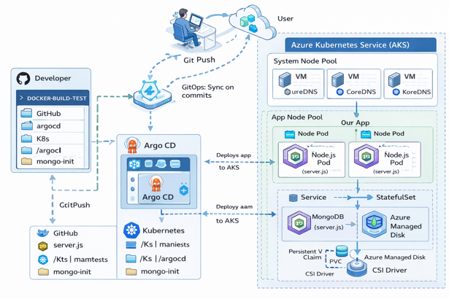

Deployment Architecture

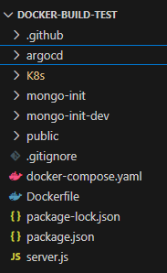

Project Repositories -

https://github.com/mainakdas73/recruit-project.git
https://hub.docker.com/repositories/mainakdas73

App Interface : http://20.37.49.5/

**Update these secrets in GitHub repository -> settings -> Secrets and variables -> Actions -> New Repository secret

DOCKER_USERNAME :mainakdas73
DOCKER_PASSWORD (token) : dckr_pat_1HvcAV29c7JT6qQuBva_Pz2nxZs
KUBE_CONFIG - (generate from cluster) cat ~/.kube/config | base64

YXBpVmVyc2lvbjogdjENCmNsdXN0ZXJzOg0KLSBjbHVzdGVyOg0KICAgIGNlcnRpZmljYXRlLWF1
dGhvcml0eS1kYXRhOiBMUzB0TFMxQ1JVZEpUaUJEUlZKVVNVWkpRMEZVUlMwdExTMHRDazFKU1VV
………….jslkl#==

Building the Infrastructure through Terraform (IAC). For setting up I need provider,resource group, AKS and persistent storage script to create the Infra in AKS (Azure cloud).

provider.tf

terraform {
required_providers {
azurerm = {
source = "hashicorp/azurerm"
version = ">= 4.0.0"
}
kubernetes = {
source = "hashicorp/kubernetes"
version = ">= 2.0.0"
}
}
}

provider "azurerm" {
features {}
subscription_id = "d008c7cc-9795-4292-bf79-74ae52cda63d"
}

resource-group.tf [Here I am using the existing resource group so instead of resource I am using data to import the data]

data "azurerm_resource_group" "rg" {
name = "LabsKraft360"
}

aks.tf [AKS - Cluster build in Azure with 4 nodes in systempool]

resource "azurerm_kubernetes_cluster" "aks" {
name = "mainak-aks"
location = data.azurerm_resource_group.rg.location
resource_group_name = data.azurerm_resource_group.rg.name
dns_prefix = "mainak"

node_resource_group = "mainak-aks-nodes"

default_node_pool {
name = "systempool"
node_count = 4
vm_size = "Standard_D2ads_v6"
type = "VirtualMachineScaleSets"
}

identity {
type = "SystemAssigned"
}

network_profile {
network_plugin = "azure"
load_balancer_sku = "standard"
}
}

Cluster details in Azure cloud after running the terraform script

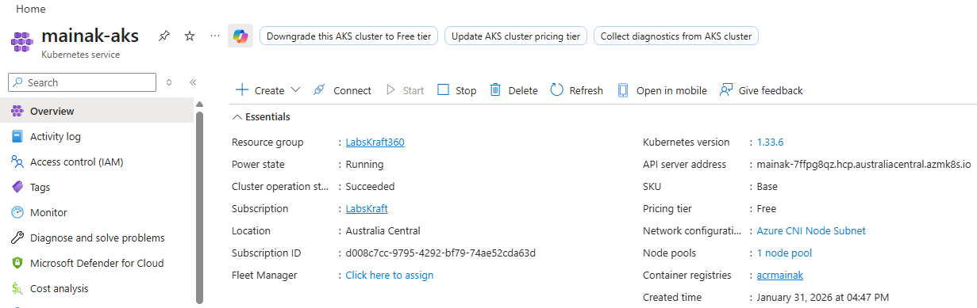

storage.tf Persistent storage visibile in Kubernetes cluster -> kubectl get storageclass

resource "kubernetes_storage_class_v1" "azure_disk" {
metadata {
name = "managed-premium-retain"
}

storage_provisioner = "disk.csi.azure.com"
reclaim_policy = "Retain"
volume_binding_mode = "WaitForFirstConsumer"

parameters = {
skuName = "Premium_LRS"
}
}

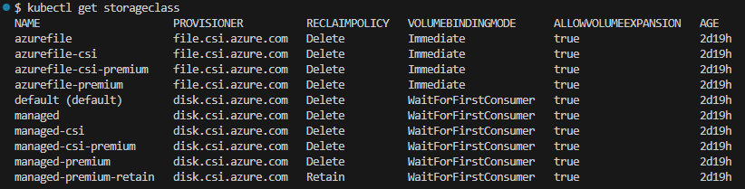

Configuration files in Repository recruit-project, branch name - hr-repo

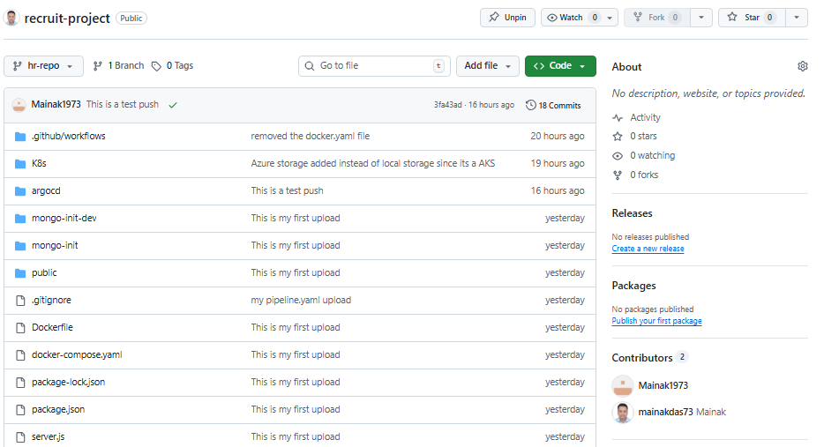

Docker Registry

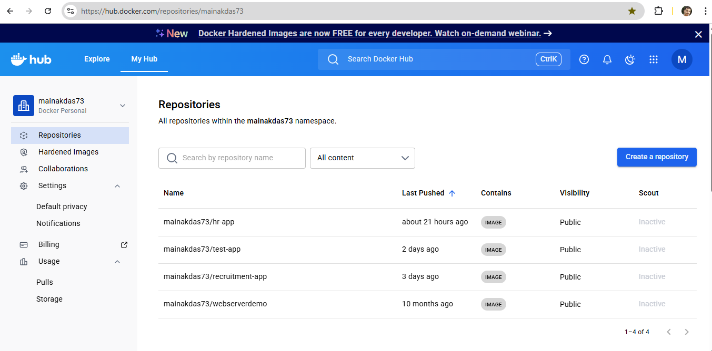

File Structure and Manifestes

.GitHub/workflows/CI-pipeline.yaml

name: HR App CI Pipeline

on:
push:
branches:
- hr-repo
workflow_dispatch:

permissions:
contents: read

jobs:
build-and-deploy:
runs-on: ubuntu-latest

steps:
- name: Checkout code
uses: actions/checkout@v4

- name: Docker Hub login
run: |
echo "${{ secrets.DOCKER_PASSWORD }}" | docker login docker.io \
-u "${{ secrets.DOCKER_USERNAME }}" --password-stdin

- name: Build Docker image
run: |
docker build -t mainakdas73/hr-app:${{ github.sha }} .

- name: Push Docker image
run: |
docker push mainakdas73/hr-app:${{ github.sha }}

- name: Tag & Push latest
run: |
docker tag mainakdas73/hr-app:${{ github.sha }} mainakdas73/hr-app:latest
docker push mainakdas73/hr-app:latest

- name: Configure kubeconfig
run: |
mkdir -p ~/.kube
echo "${{ secrets.KUBE_CONFIG }}" | base64 -d > ~/.kube/config

- name: Deploy to Kubernetes
run: |
kubectl set image deployment/recruitment-app \
hr-app=mainakdas73/hr-app:${{ github.sha }} \
-n docker-ns

Manifests in /K8s

app-deployment.yaml

apiVersion: apps/v1
kind: Deployment
metadata:
name: recruitment-app
namespace: docker-ns
spec:
replicas: 2
selector:
matchLabels:
app: recruitment-app
template:
metadata:
labels:
app: recruitment-app
spec:
containers:
- name: hr-app
image: mainakdas73/hr-app:1.0
ports:
- containerPort: 3000
env:
- name: MONGO_URL
value: mongodb://mongo:27017/testdb
readinessProbe:
httpGet:
path: /health
port: 3000
initialDelaySeconds: 30
periodSeconds: 10
livenessProbe:
httpGet:
path: /healthz
port: 3000
initialDelaySeconds: 60

app-service.yaml

apiVersion: v1
kind: Service
metadata:
name: recruitment-app-service
spec:
selector:
app: recruitment-app
ports:
- port: 80
targetPort: 3000
nodePort: 30080
type: LoadBalancer

mongo-configmap.yaml

apiVersion: v1
kind: ConfigMap
metadata:
name: mongo-config
namespace: docker-ns
data:
MONGO_HOST: mongo
MONGO_PORT: "27017"
MONGO_DB: hr_system

mongo-deployment.yaml

apiVersion: apps/v1
kind: Deployment
metadata:
name: mongo
namespace: docker-ns
spec:
replicas: 1
selector:
matchLabels:
app: mongo
template:
metadata:
labels:
app: mongo
spec:
containers:
- name: mongo
image: mongo:6.0
ports:
- containerPort: 27017

# MongoDB auth initialization
env:
- name: MONGO_INITDB_ROOT_USERNAME
valueFrom:
secretKeyRef:
name: mongo-secret
key: username

- name: MONGO_INITDB_ROOT_PASSWORD
valueFrom:
secretKeyRef:
name: mongo-secret
key: password

- name: MONGO_INITDB_DATABASE
valueFrom:
configMapKeyRef:
name: mongo-config
key: MONGO_DB

volumeMounts:
- name: mongo-persistent-storage
mountPath: /data/db

volumes:
- name: mongo-persistent-storage
persistentVolumeClaim:
claimName: mongo-pvc

mongo-secret.yaml

apiVersion: v1
kind: Secret
metadata:
name: mongo-secret
namespace: docker-ns
type: Opaque
data:
username: aHJhcHA=
password: aHJhcHAxMjM=

mongo-service.yaml

apiVersion: v1
kind: Service
metadata:
name: mongo
namespace: docker-ns
spec:
selector:
app: mongo
ports:
- port: 27017
targetPort: 27017

mongo-pvc.yaml

apiVersion: v1
kind: PersistentVolumeClaim
metadata:
name: mongo-pvc
namespace: docker-ns
spec:
accessModes:
- ReadWriteOnce
storageClassName: managed-csi <-- selecting Azure disk
resources:
requests:
storage: 5Gi

$ kubectl get storageclass
NAME PROVISIONER RECLAIMPOLICY VOLUMEBINDINGMODE ALLOWVOLUMEEXPANSION AGE
managed-csi-premium disk.csi.azure.com Delete WaitForFirstConsumer true 2d

[ ** Incase of Azure disk, no PV is required only storageclass name needs to be mentioned and there is no requirement for mongo-pv.yaml]

namespace.yaml

apiVersion: v1
kind: Namespace
metadata:
name: docker-ns

Cluster Configuration

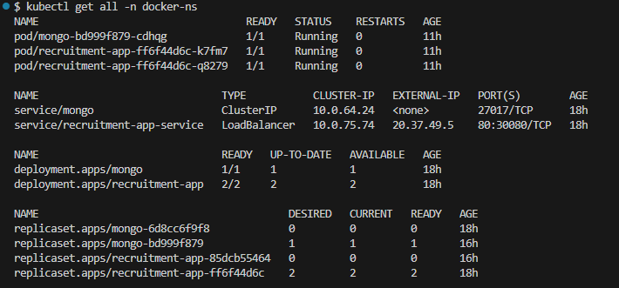

**The argocd yaml file is to implement in Kubernetes cluster and pull the image from Docker registry.

/argocd/argocd.yaml

apiVersion: argoproj.io/v1alpha1
kind: Application
metadata:
name: hr-app
namespace: argocd
spec:
project: default
source:
repoURL: https://github.com/mainakdas73/recruitment-project.git
path: K8s
targetRevision: hr-repo
destination:
server: https://kubernetes.default.svc
namespace: docker-ns
syncPolicy:
automated:
prune: true
selfHeal: true

After Installing argocd in Kubernetes cluster and running the yaml file will create the application in argocd namespace.

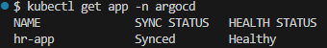

Container Image Build Strategy

Dockerfile

FROM node:18-alpine

WORKDIR /app
COPY package*.json ./
RUN npm install --production
COPY . .
EXPOSE 3000
CMD ["node", "server.js"]

The Dockerfile defines the standardized image build process. During each build:
  - A Node.js base image is used
  - Application dependencies are installed based on package.json
  - Application source code and static assets are copied into the image
  - A new immutable container image is produced
CI/CD Integration
A Continuous Integration pipeline is responsible for:
- Detecting source code changes in the repository
- Building a new container image using the Dockerfile
- Tagging the image according to the release strategy
- Pushing the image to a centralized Docker Hub (container registry)
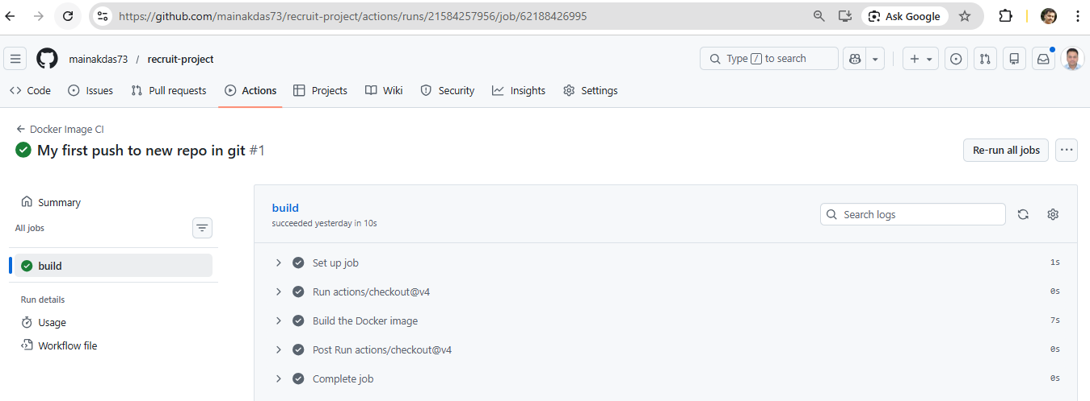
MONITORING

Argocd Interface : http://20.37.1.13 user name - admin, password - OeOOG5akdhyaJFqO

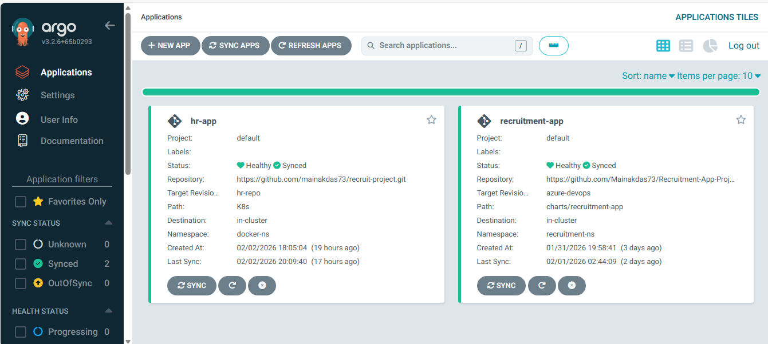

Configuring Grafana (getting Prometheus IP to create a connection in Grafan)

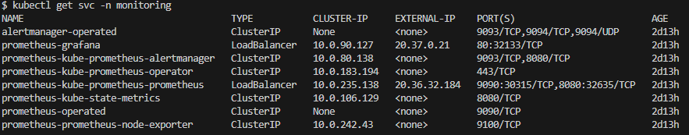

Grafana Interface: http://20.37.0.21 (Prometheus configuration)

[pwd - K8XpsnvHcP7U6uScE7IRGi6cuGb73EVhfFsz1BmT]
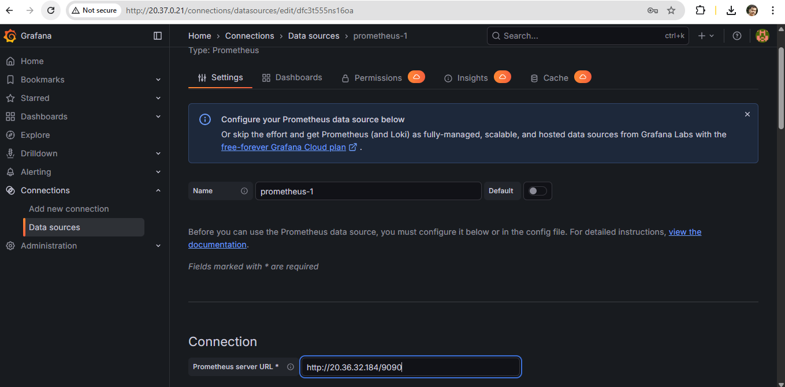

CPU/Memory Monitoring Namespace – docker-ns

